University Shuttle Service : website

**By**

**Hossain Ahammed**

**ID: 221-15-4694**

**Fabiha Chowdhury**

**Momo**

**ID: 221-15-5092**

**Somiya Akter**

**ID: 221-15-5696**

**Submitted To**

**Md.Ashraful Islam Talukder Lecturer**

**Department of CSE Daffodil International University**



**DAFFODIL INTERNATIONAL UNIVERSITY DHAKA,BANGLADESH**

**FALL 2023**

**TABLE OF CONTENTS**

**CHAPTER 1**

* 1. Introduction
  2. Motivation
  3. Objectives
  4. Expected Outcome
  5. Report Layout

**CHAPTER 2**

* 1. Introduction
  2. Related Work
  3. Comparative Studies
  4. Challenges

**CHAPTER 3**

* 1. Design Overview
  2. Design Elements
     1. Header
     2. Available navigation bar
     3. Services
     4. Content
     5. Footer
     6. Log-In
     7. Sign-Up

## INTRODUCTION

### Introduction

This document is about creating a website for the university shuttle service. The goal is to simplify transportation on campus by allowing students and staff to easily find and book rides online.

The website will have a straightforward design, featuring a homepage with a search bar, ride information, and quick links to popular destinations. Users can create accounts to manage their bookings, and the site will showcase different ride options, like shuttles, with details on capacity and routes.

Objectives:

**1. Simplicity:** Create a user-friendly website for hassle-free ride bookings.

**2. Convenience**: Enable users to easily search, select, and book rides online.

**3. Accessibility**: Ensure the website is accessible from anywhere on campus.

**4. Modernization**: Bring the university shuttle service in line with current online practices.

The document structure includes an introduction, goals, website layout description, implementation plan, benefits, challenges and solutions, and a conclusion. The project aims to enhance campus transportation by leveraging the convenience of online booking.

#### **Motivation**

1. **Current Situation**: Right now, getting a ride at the university is not very easy. Most of the transportation services work offline, and there aren't many online options. This gives us a chance to make a new online service that is easy to use and convenient for everyone.

2. **More Choices**: Our platform will stand out because it will offer more types of rides than what's available now. Besides regular cars, we'll have buses, ambulances, and other special vehicles. This means we can help with all sorts of transportation needs around the university.

In simple terms, we're starting this project because it's not easy to get a ride at the university right now, and we want to make it better by creating an online service. Our service will also have more types of rides than what's available, making it more useful for different transportation needs on campus.

### 1.3 Objectives

● Save Time and Effort: You won't have to go to any office to get a university shuttle. It's all online, so it's quick and easy.

● More Choices of Rides: Besides shuttles, you can pick from different types of vehicles like buses and ambulances. This way, we cover all kinds of transportation needs around the university.

● Modern and Easy: We're introducing a new and smart way to book university shuttles online. This makes things more up-to-date and modern for everyone on campus.

#### **1.4 Expected Outcome**

1.The online platform makes it easy for you to pick and book the university shuttles you need. You can do this from anywhere, using your phone or computer, anytime you want. No need to go to any offices – it's a time-saver!

2.We offer more types of rides than others – not just shuttles but also cars, buses, and ambulances. This way, you can find the perfect ride for whatever you need on campus.

3.We keep things clear and simple. You'll always know how much it costs and the rules for renting. This helps you trust and rely on our service for all your university transportation needs.

#### **Report Layout**

This project has a total four part. In chapter one we will discuss introduction, motivation, objectives, expected outcome. In chapter two we will discuss background studies including introduction, related works, challenges. In chapter three we will talk about design specification and finally conclusion.

**CHAPTER 2**

**BACKGROUND**

#### **2.1 Introduction**

A lot of people face problems when they try to get a ride for different reasons or tasks. This can be even more tricky when it's for a longer time or if you need to carry something heavy. We're thinking about a solution that fits our university. We want to create a system where people who know how to do a specific job can really help others.

Our goal is to make it simple for anyone at the university to get a ride for whatever they need. Whether it's for a short or long time, or if you have something heavy to carry, we want to make it easy to find the right ride for the job.

#### **2.2 Related Work**

1. **User-Friendly Booking:**

Like Uber, make it easy for students to book a ride using a simple app or website. A few taps, and they're good to go.

2**. Real-Time Tracking:**

Provide a feature where students can track the shuttle's location in real-time. This helps them know exactly when it will arrive.

3. **Transparent Pricing:**

Just like Uber shows the fare upfront, make the shuttle service pricing clear. No surprises for the students.

4. **Driver Ratings and Feedback:**

Allow students to rate their shuttle experience and provide feedback. This helps improve the service and ensures quality.

5. **Flexibility in Vehicle Options:**

Uber has different vehicle options. Similarly, offer various shuttle sizes to accommodate different group sizes or needs.

6. **Cashless Transactions:**

Keep it simple by having cashless transactions. Students can pay for the ride using the app or online, reducing hassle.

7. **Accessibility Features**:

- Consider accessibility features in the shuttle service, ensuring it's available and usable for everyone on campus.

8. **Promotions and Discounts:**

- Introduce promotions or discounts for regular riders or during specific times to encourage more students to use the service.

#### **2.3 Comparative Studies**

Looking at all the vehicle services in our country, we see they're all helpful in different ways. However, each has its limits. Our platform aims to fill some of these gaps. Here's what we offer for university shuttle service:

1. **Rent Anywhere, Anytime:**

- You can rent a car at any tourist spot in the country for a specific day. Need multiple cars for a wedding? No problem.

3. **Experienced Drivers as Guides:**

- Our drivers aren't just drivers. They know the country's tourism well and can guide you. Especially useful for those exploring new places.

4. **Trained Goods Transport:**

- If you need to move things, our drivers are trained for that. You can trust them with your goods.

It's a solution for various needs on the university campus, making transportation easy and reliable for everyone.

#### **Challenges**

1. **Traffic Jams:**

Sometimes, the roads around universities get really crowded. This can make the shuttles run late.

2. **Different Schedules:**

Students and staff have all sorts of different schedules. Figuring out a timetable that suits everyone is not easy.

3. **Not Enough Shuttles:**

- Sometimes, there aren't enough shuttles available. This means not everyone might get a ride when they need it.

4. **Weather Issues:**

Bad weather, like rain or snow, can cause problems. It might slow down the shuttles or even stop them.

5. **Shuttle Breakdowns:**

Shuttles need regular check-ups. If one breaks down unexpectedly, it can mess up the whole schedule.

6. **Keeping Everyone Safe:**

Making sure everyone is safe during the ride is super important. If there are safety worries, we need to fix them fast.

7. **Changing Demand:**

Sometimes, more people need rides, and sometimes fewer. Predicting these changes can be tricky.

8. **Communication Problems:**

If we don't tell people about changes in the shuttle schedule, it can cause confusion.

9. **Special Events and Breaks:**

Big events or holidays can mess up the usual shuttle plans. We need to plan for these changes.

**Chapter 3**

## Design specification

**Header :**

The header consists of the logo, a navigation bar, and sign-in/sign-up options. The logo is prominently displayed on the left, while the navigation bar provides easy access to the main sections of the website. Sign-in options are conveniently placed on the right side of the login button.

#### **3.2.2 Available Navigation Bar:**

* + 1. **Services**

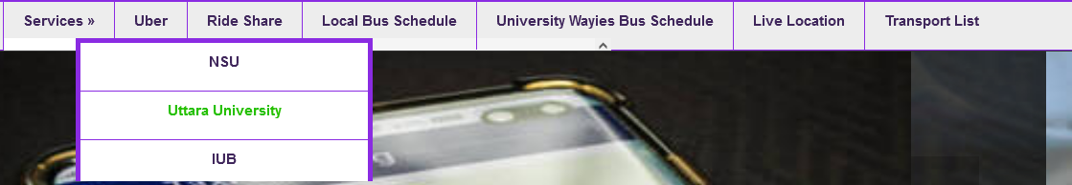

#### **3.2.3 content:**

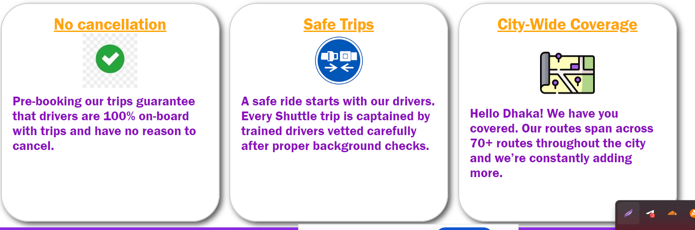

**3.2.4 Footer:**



**3.2.5 Login:**

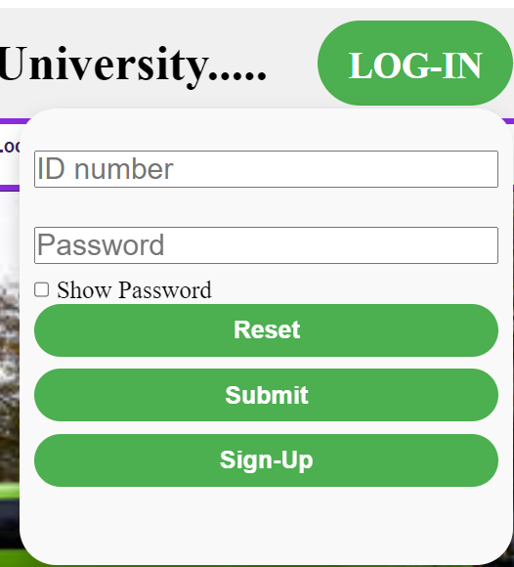

**3.2.6 Sign-Up:**

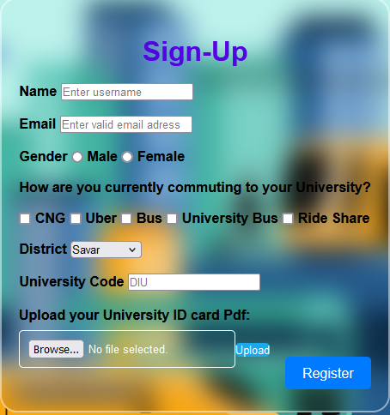

**Conclusion**

This project uses HTML, CSS, and JavaScript to create a user-friendly experience. We've designed it with simplicity in mind. As we go along, we'll test it to find any issues and make it even more user-friendly. Our goal is to build a platform that serves the people, starting from the capital and expanding in the future. We're determined to face the challenges that come our way. Most importantly, this platform aims to make it easy for Student to get Transport for University.